Ideation Phase
Brainstorm & Idea Prioritization Template
Date | 31 January 2025
Team ID
Project Name
Maximum Marks | 4 Marks

Brainstorm & Idea Prioritization Template:
Brainstorm & Idea Prioritization
Brainstorming for AI WeatherWise provides a creative environment where team members can freely share ideas for improving weather forecasting, user experience, and AI-powered weather insights. The brainstorming process focuses on understanding the difficulties users face when interpreting raw weather information and finding practical ways to convert it into simple and useful recommendations.
The team encourages ideas related to real-time weather updates, favorite location management, AI-generated weather summaries, travel recommendations, activity suggestions, clothing recommendations, secure user authentication, and personalized weather insights. All ideas are welcomed initially without judging their feasibility, allowing team members to build upon each other's suggestions.
After generating a wide range of ideas, the team prioritizes them based on user usefulness, technical feasibility, reliability, security, and potential impact. This helps identify the most valuable features for AI WeatherWise and guides the development of a practical, scalable, and user-friendly weather intelligence platform.

Step-1: Team Gathering, Collaboration and Select the Problem Statement
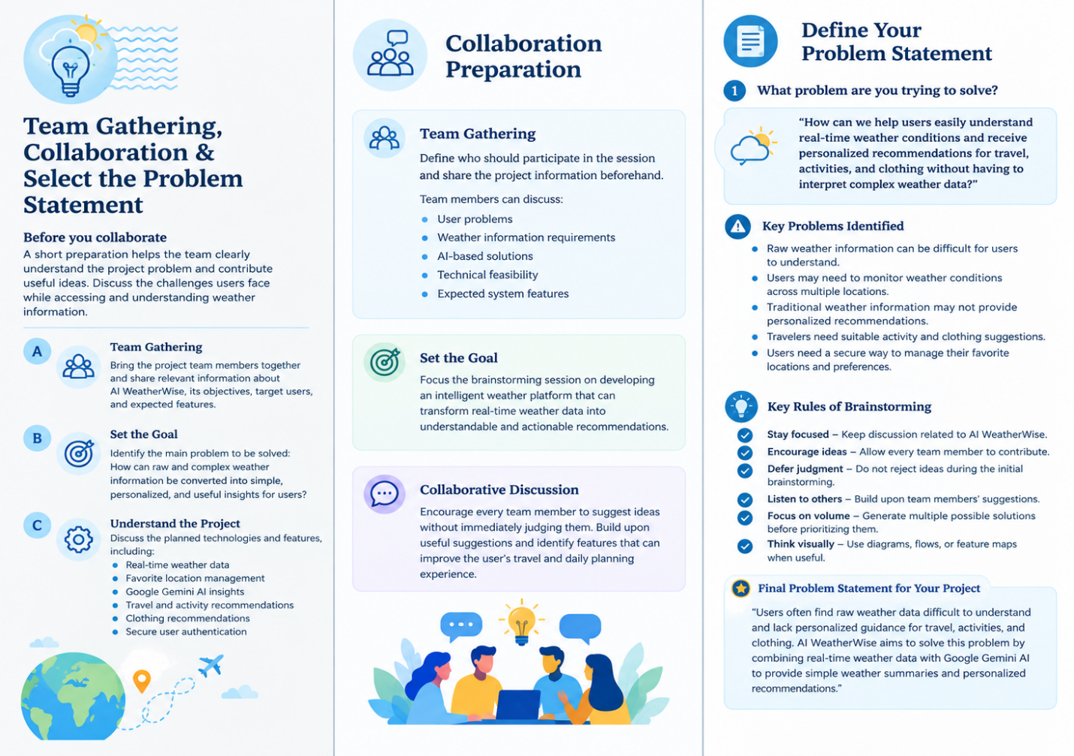
Step-2: Brainstorm, Idea Listing and Grouping
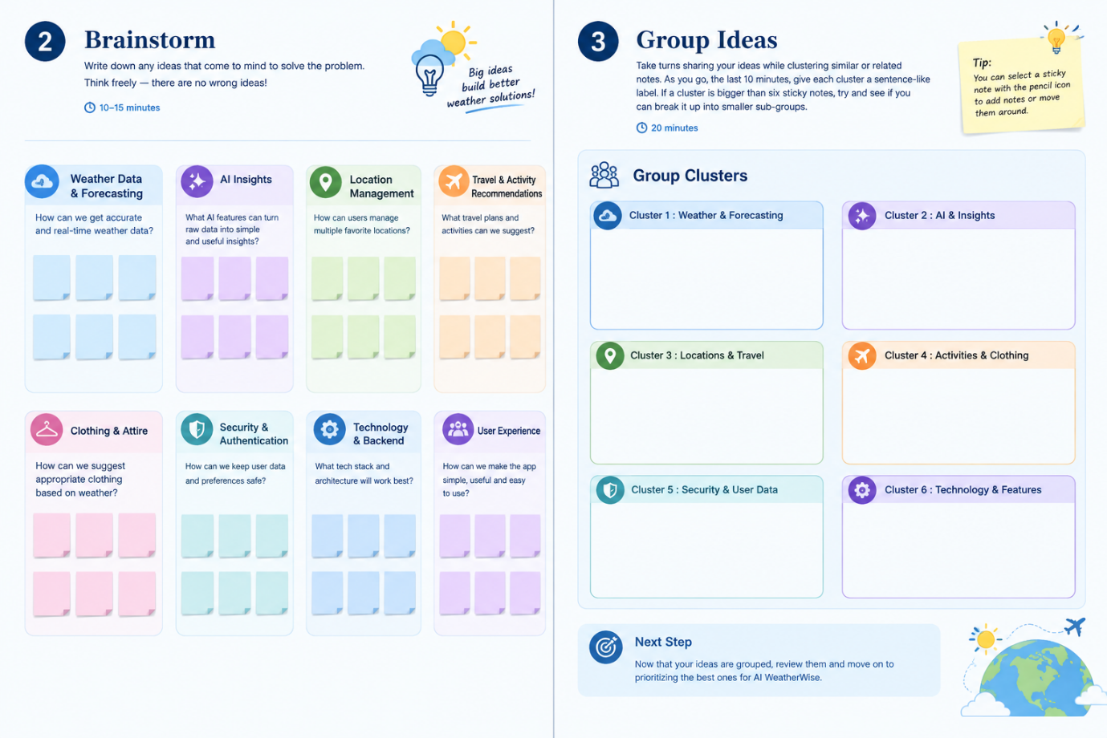
Step-3: Idea Prioritization
